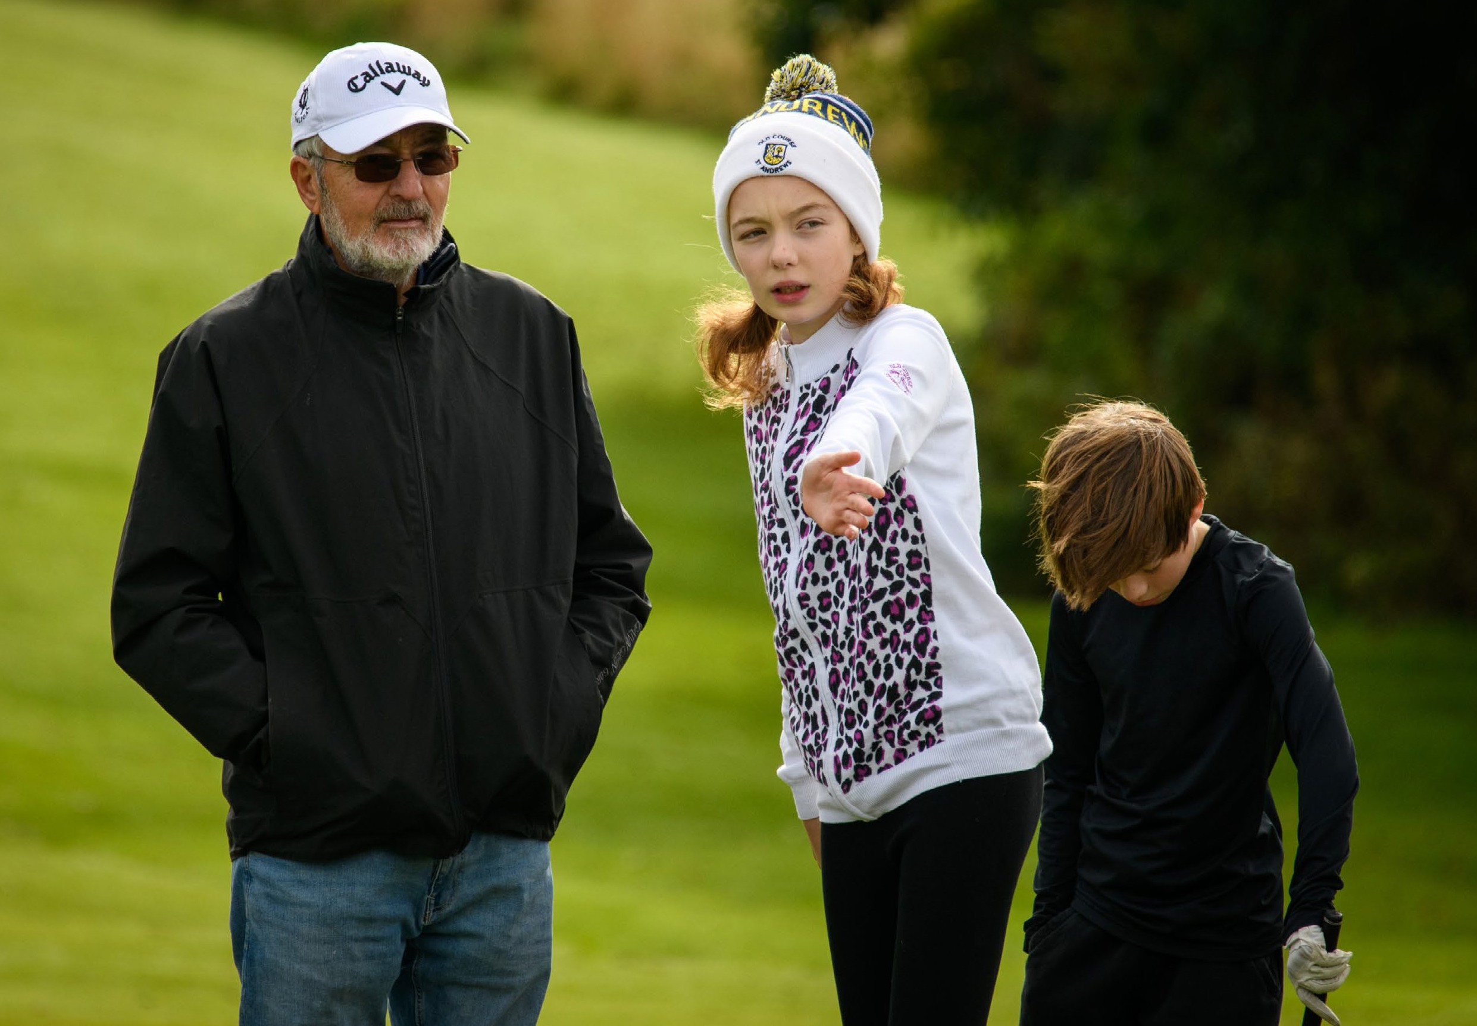
Safeguarding Handbook

Scottish Golf
A female junior studies a putt at the Golf Sixes East Regional held at Milnathort Golf Club on September 25, 2022.

Practice To Be Avoided
In the context of your role at Angus County Golf Association, the following practice should be avoided:
- Having ‘favourites’ – this could lead to resentment and jealousy by other players and could be misinterpreted by others.
- Spending excessive amounts of time alone with children and vulnerable adults away from others.
- Entering player’s bedrooms on trips away from home, unless in an emergency situation or in the interest of health and safety. If it is necessary to enter rooms, alert the occupants by knocking and announcing your intention to enter. The door should remain open, if appropriate.
- Where possible, doing things of a personal nature for children and vulnerable adults that they can do for themselves.
- Making contact or holding discussions with children via social networking sites or texting.

Practice Never to Be Sanctioned
In the context of your role at Angus County Golf Association, the following practices will never be sanctioned:
- Engaging in sexually provocative games, including horseplay.
- Forming intimate emotional, physical or sexual relationships with children and vulnerable adults.
- Allowing or engaging in touching a player in a sexually suggestive manner.
- Allowing players to use inappropriate or sexualised language unchallenged.
- Making sexually suggestive comments to a player, even in fun.
- Reducing a player to tears as a form of control.


- Allowing allegations made by a player to go unchallenged, unrecorded or not acted upon.

CODE OF CONDUCT
- Inviting or allowing players to stay with you at your home.
- Coaches and leaders sharing a room alone with a player for sleeping accommodation.

COACHES AND VOLUNTEERS

Good Practice
In the context of your role at Angus County Golf Association, the following good practice guidelines should be followed:
- Make golf fun, enjoyable and promote fair play.
- Treat all players equally, with respect, dignity and fairness.
- Involve parents, carers and carers wherever possible.
- Build balanced relationships based on mutual trust that empower and include children and vulnerable adults in the decision-making process.
- Always work in an open environment. Avoid private or unobserved situations.
- Put the welfare of each player first before winning or achieving performance goals.
- Be an excellent role model including not smoking or drinking alcohol in the company of children.
- Give enthusiastic and constructive feedback rather than negative criticism.
- Recognise the developmental needs and capacity of children and vulnerable adults and avoid excessive training and putting undue pressure on them
- Allowing the right (UNCRC) for a child to express views freely in all matters affecting them
All concerns about breach of this Code of Conduct will be taken seriously and responded to in line with Angus County Golf Association Responding to Concerns procedure.
- I am aware that if I have seen and read the ‘Respond to Concern’ guidance and that if a player or parent/carer raises a concern I have a duty of care to report this to Angus County Golf Association’s Safeguarding Officer.
- I am aware that if I have a concern or would like to talk to somebody, I can contact Scottish Golf’s Safeguarding team by email safeguarding@scottishgolf.org or by telephone 07812665164
- I have read and understood this Code of Conduct and I agree to abide by the rules and guidelines of the Club.

Name (print) .......................................... Signed ..........................................
Role .......................................... Date ......................................

